Experiment-1.1

Aim of the Experiment : Accessing the colored/grayscale image/video elements.
- Accessing the colored/grayscale image elements.
- Accessing the video elements, choosing random frame and grayscale it.

- ACCESSING THE COLORED/GRAYSCALE IMAGE ELEMENTS:
Problem Description :
An RGB image consists of three images ( a red scale image, a green scale image and a blue scale image) stacked on top of each other. In MATLAB, an RGB image is a M*N*3 array of color pixel, where each color pixel is a triplet which corresponds to red, blue and green color component of RGB image at a specified spatial location.
A Grayscale image is a single layered image. In MATLAB, a grayscale image is basically M*N array whose values have been scaled to represent intensities. In MATLAB, there is a function called rgb2gray() is available to convert RGB image to grayscale image.
The formula to convert RGB image into GrayScale image is:
GrayScale = (R * 0.2989) + (G * 0.5870) + (B * 0.114)

Code for Experiment :
% Read color image
color_image = imread('lena_color.png');
subplot(2,4,1), imshow(color_image)
title("Original Image")

% Breakdown RGB image into R, G and B components
R=color_image(:, :, 1);
subplot(2,4,2), imshow(R)
title("R");

G=color_image(:, :, 2);
subplot(2,4,3), imshow(G)
title("G");

B=color_image(:, :, 3);
subplot(2,4,4), imshow(B);
title("B");

% Convert each pixel of RGB image into grayscale image
gray_image=(R*0.2989)+(G*0.5870)+(B*0.114);
subplot(3,3,5), imshow(gray_image);
title("Standard GrayScale")

gray_image1=(R*0.1989)+(G*0.4870)+(B*0.214);
subplot(3,3,6), imshow(gray_image1);
title("Customised GrayScale1")
gray_image2=(R*0.3989)+(G*0.4870)+(B*0.314);
subplot(3,3,7), imshow(gray_image2);
title("Customised GrayScale2")
gray_image3=(R*0.3989)+(G*0.7870)+(B*0.514);
subplot(3,3,8), imshow(gray_image3);
title("Customised GrayScale3")

% Combine the three components back into image
rgbImage = cat(3, gray_image1, gray_image2, gray_image3);
subplot(3,3,9), imshow(rgbImage)
title("Combined Image")

sgtitle('Ashish Kumar, 23MAI10008')

Result/Output :
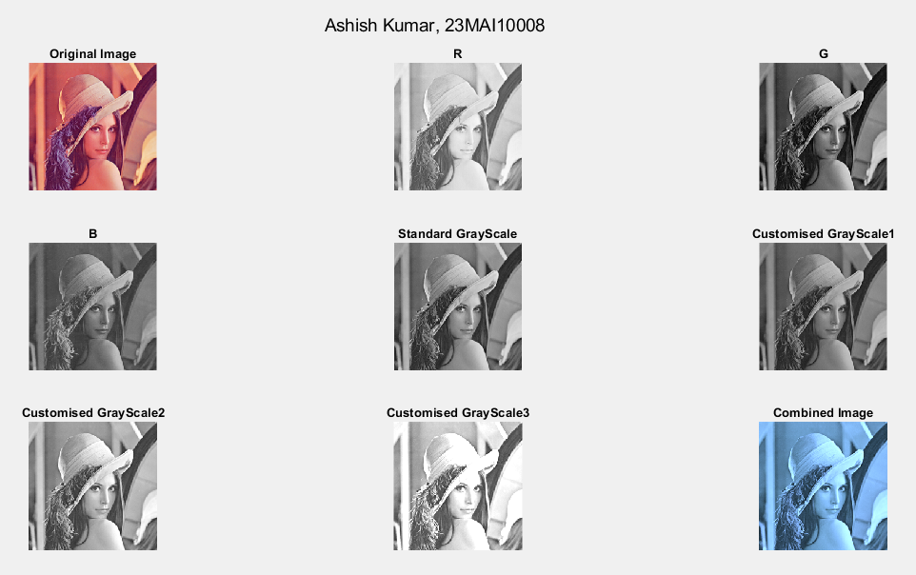

- ACCESSING THE VIDEO ELEMENTS, RANDOM FRAME AND GRAYSCALE IT:
Problem Description :
The frame is a combination of the image and the time of the image when exposed to the view. We can use the VideoReader class to set the starting time of the video, then use read() to extract a frame from the video at exactly that time.
randi(): randi([1,y]) generates a random number in between 1 and y. Then we can use this random number to access the random frame from the Video.
read(): read(VideoObj,Rframe) function read the random frame from the Video.

Code for Experiment :
% Create a video reader
VideoObj = VideoReader('Video Cartoon.mp4');

% Count Total frames in video
framecount=VideoObj.NumFrames;
X = ['Total Frames in Video: ',num2str(framecount)];

% Select a Random frame
Rframe = randi([1,framecount]);
Y = ['Random Frame Number: ',num2str(Rframe)];
Frame = read(VideoObj,Rframe);
subplot(3,3,1), imshow(Frame)
title('Original')

R=Frame(:, :, 1);
subplot(3,3,2), imshow(R)
title("R");

G=Frame(:, :, 2);
subplot(3,3,3), imshow(G)
title("G");

B=Frame(:, :, 3);
subplot(3,3,4), imshow(B)
title("B");

% Convert each pixel of RGB image into grayscale image
gray_image=(R*0.2989)+(G*0.5870)+(B*0.114);
subplot(3,3,5), imshow(gray_image)
title("Standard GrayScale")

% Convert each pixel of RGB image into grayscale image
gray_image1=(R*0.7989)+(G*0.5870)+(B*0.114);
subplot(3,3,6), imshow(gray_image1)
title("Customised GrayScale1")

% Convert each pixel of RGB image into grayscale image
gray_image2=(R*0.2989)+(G*0.9870)+(B*0.114);
subplot(3,3,7), imshow(gray_image2)
title("Customised GrayScale2")

% Convert each pixel of RGB image into grayscale image
gray_image3=(R*0.2989)+(G*0.5870)+(B*0.114);
subplot(3,3,8), imshow(gray_image3)
title("Customised GrayScale3")

% Combine the three components back into image
rgbImage = cat(3, gray_image1, gray_image2, gray_image3);
subplot(3,3,9), imshow(rgbImage)
title("Combined Image")

sgtitle(["Ashish Kumar, 23MAI10008",X,Y])

Result/Output :

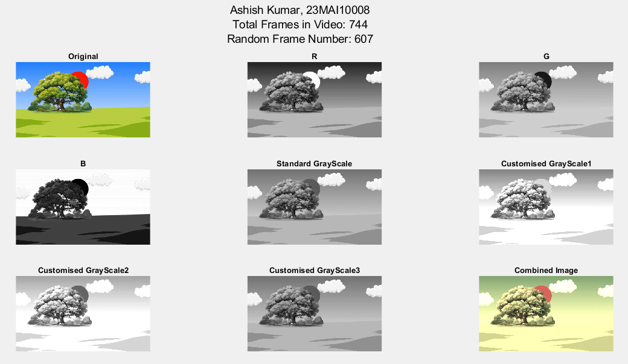

Learning outcomes (What I have learnt):
- I learnt about how to read a color image.
- I learnt about how to convert a color image into grayscale image.
- I learnt about R, G and B component of image.
- I learnt about how to read a video and frame in video.
- I learnt about how to select a random frame from video.

